Homework Assignment 5, CS696, Applied Computer Vision

Hsuan Yu, Liu 823327369

**My algorithm and decision,**

At beginning, the flower images are not same sizes, so I cropped those images into 500x450 images from centroid. Moreover, I developed the classifiers into three respectively scripts, main_HOC_SVM.m, main_HOG_SVM.m, and main_SIFT_SVM.m.

Three types of features:

1. Histogram of Color: (In main_HOC_SVM.m)

An image has RGB layers, so I computed three histograms for each layer and normalized each histogram to unit. Also, I used 30 bins for each layer. Thus, each image has 90 features.

2. Histogram of Gradient: (In main_HOG_SVM.m)

Before extracting features, I converted color to grayscale. After converted, I used MATLAB built-in function, extractHOGFeatures, to get HOG features.

3. SIFT-like: (In main_SIFT_SVM.m)

It contains three other functions, get_interest_points, get_features, and buildBagOfVisualWord. First two functions are the same functions in last assignment, Assignment 4. That is because each image gets more than one features, so I have to combine those features. Thus, I applied Bag of Visual Word model to transform the features.

At beginning, I would get all the descriptors of train data and use K mean to cluster in the number of features for SVM training. After got categories, using a center descriptor in each category represents the category. Secondly, after got a codewords, used it to compute the histogram from codewords. The histogram is a 1x(Number of words) vector, and it’s a features for SVM. I used 500 to be the number of words.

Some setting of SIFT:

1. features size = [16, 16]

2. K= 0.06

2. Interesting Point: A point whose Harris corner score is larger than 0.005*(The highest score)

**Results of three type of features:**

I ran 3 times for each of type.

1. Histogram of Color:

1st time:

Accuracy: 0.7

Failure examples:

GT=3 Predict=1 GT=2 Predict=3 GT=3 Predict=2

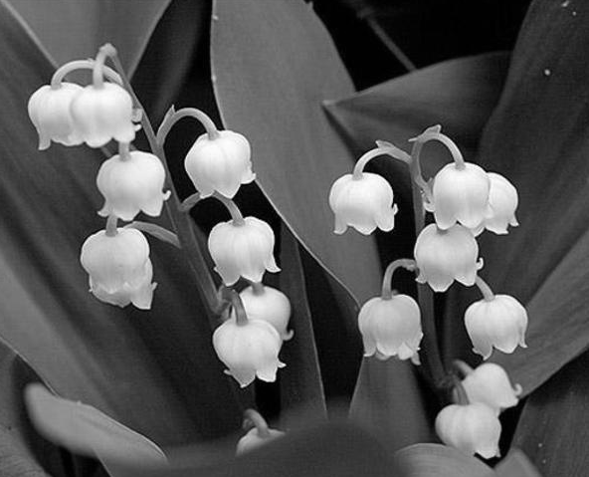 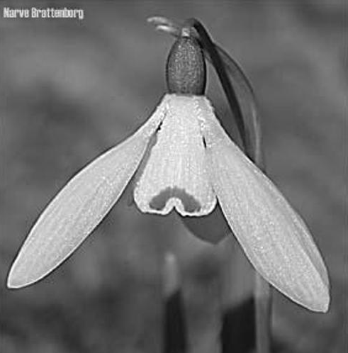 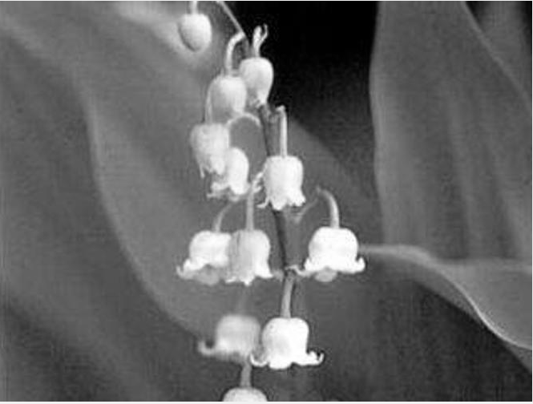

2nd time:

Accuracy:

Failure examples:

3rd time:

Accuracy:

Failure examples:

2. Histogram of Gradient:

2nd time:

Accuracy: 0. 455556

Failure examples:

3. SIFT-like:

2nd time:

Accuracy: 0. 455556

Failure examples:

GT=1 Predict=3 GT=2 Predict=1 GT=2 Predict=3

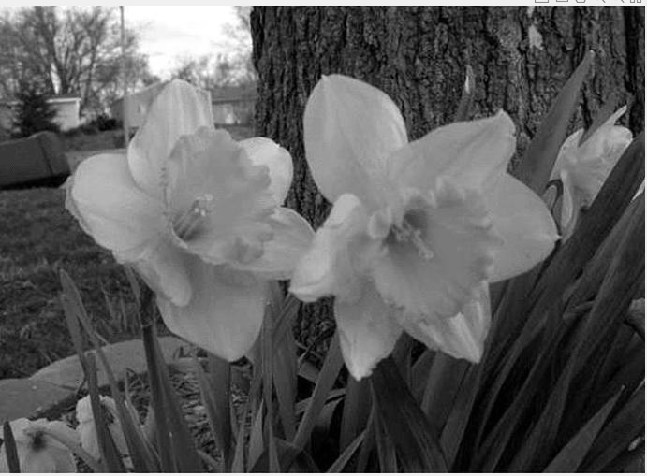 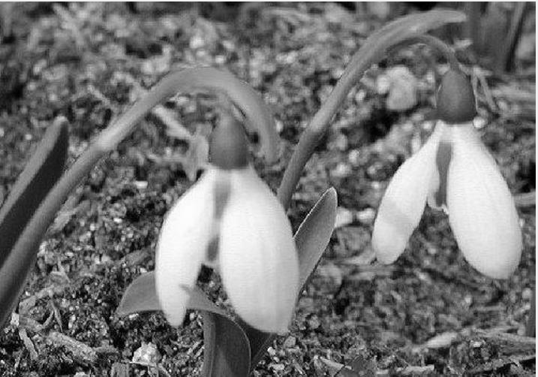 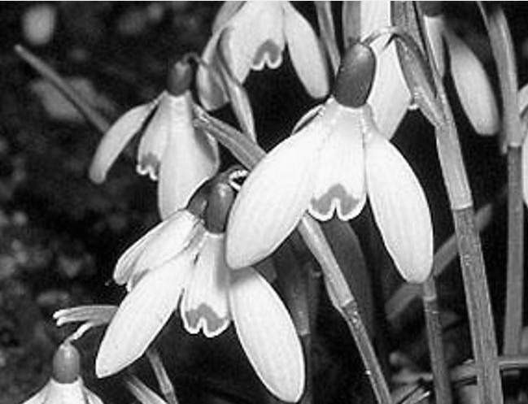

**Conclusion:**

Increasing Harris score threshold can get more interesting points. This can improve the accuracy, so I will keep the interesting around one thousand.

Another parameter, thresholds of NNDR. Greater threshold gets less features. Lower threshold gets more features. However, it’s not the more features, the better. In my report, I used 0.6, 0.7, 0.8 to get features. Finally, the accuracy can approach to 85%.